**Housing**

1. Number of new apartments/houses built in each state in the most recent years

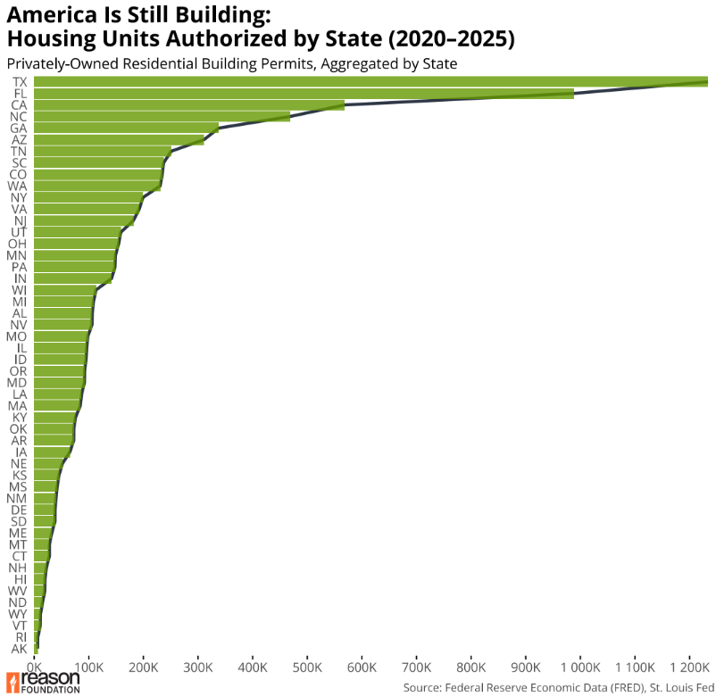

1. Top 10 states with highest new apartments/houses built in each state in the most recent years

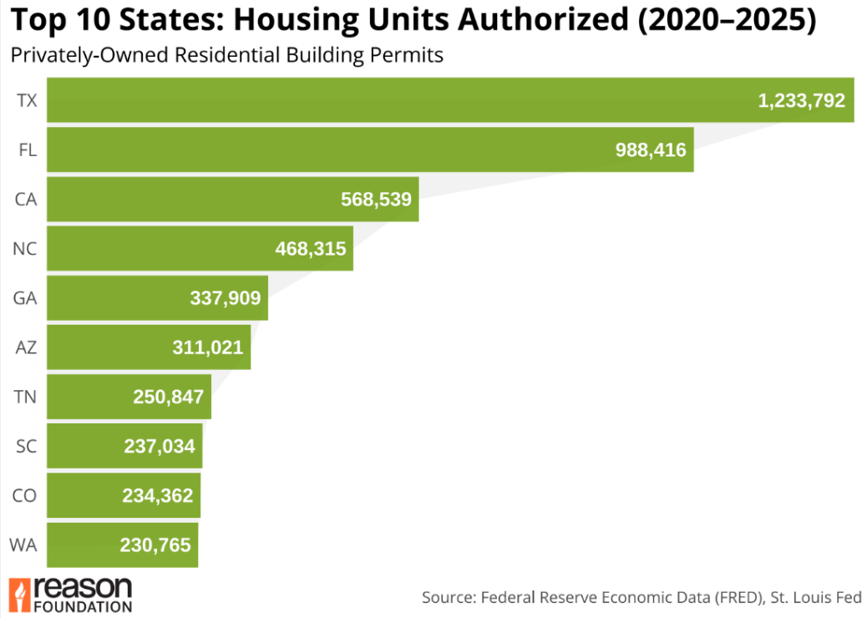

1. Number of apartments/houses per X residents built in each state in the most recent year – Fredr

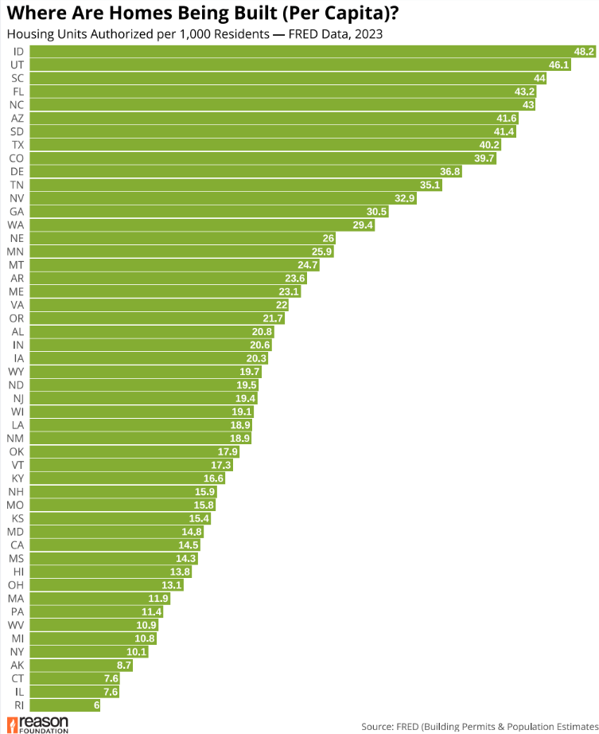

1. Number of apartments/houses built in each of the 50 largest cities in the most recent year

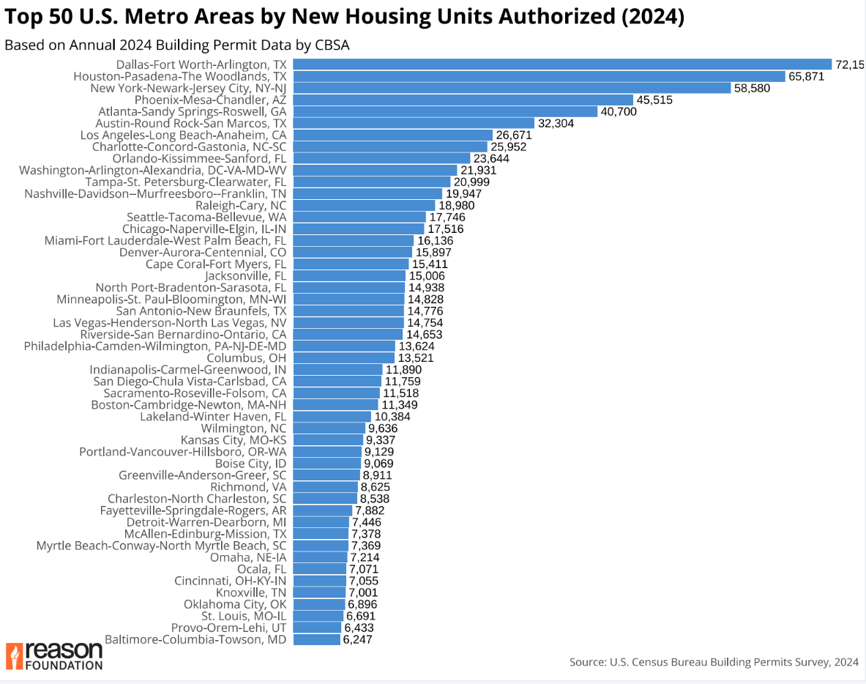

1. Total number of houses built in each state over the past 10 years – Fredr

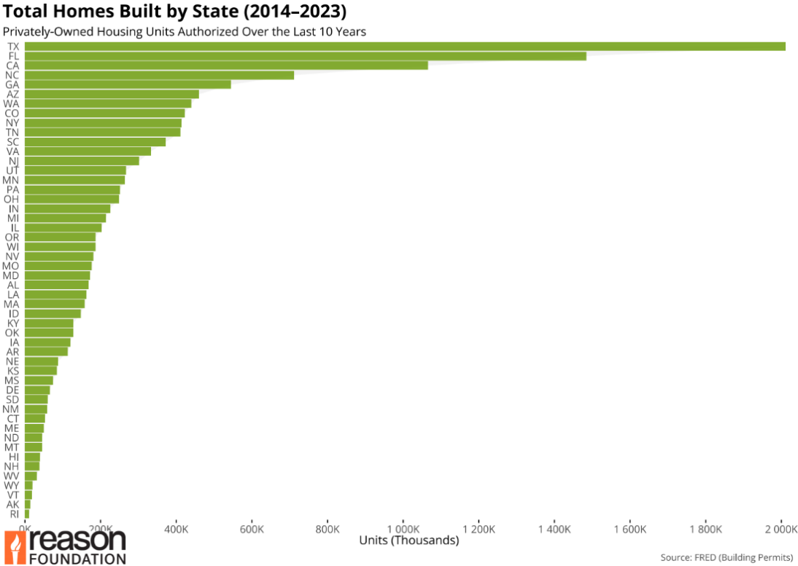

1. Median home price in each of the 50 largest cities in the most recent year

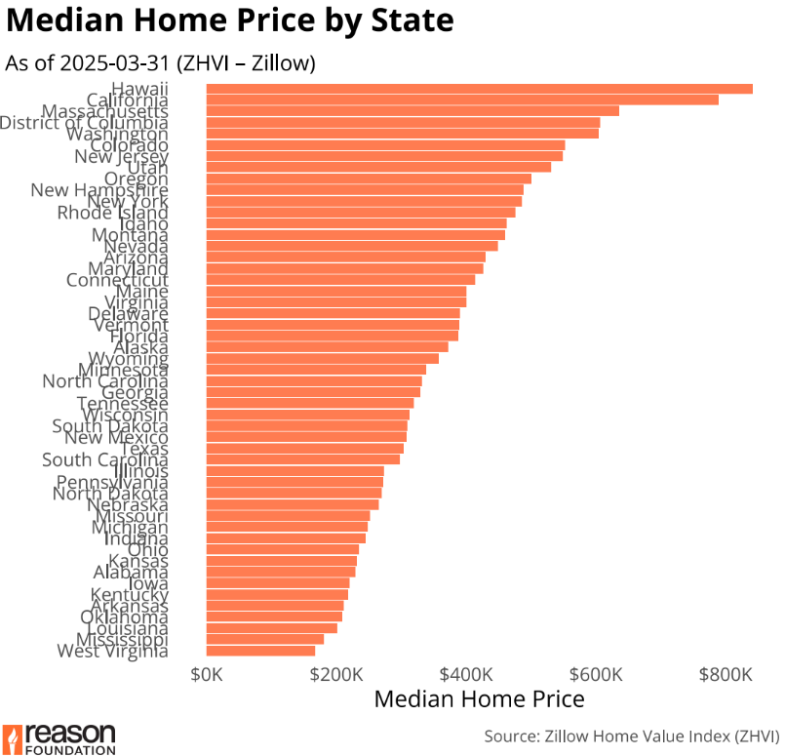

1. Median home price in each state in the most recent year

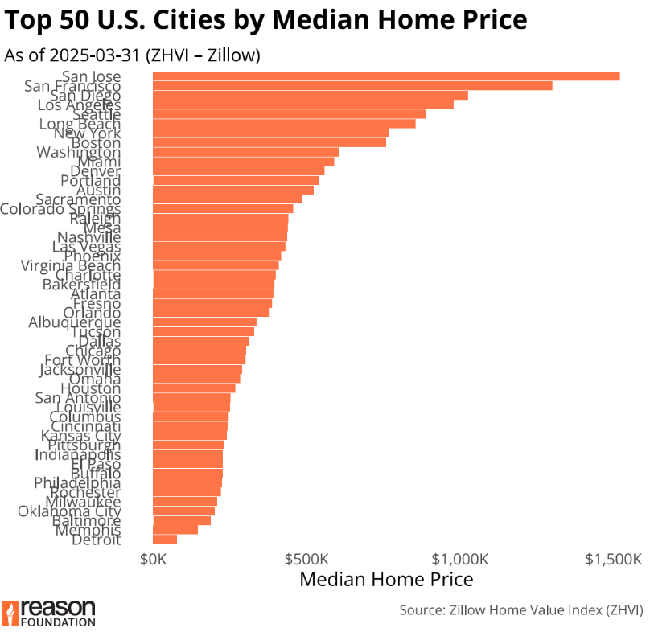

1. Average personal home property tax bill in 50 largest cities/counties

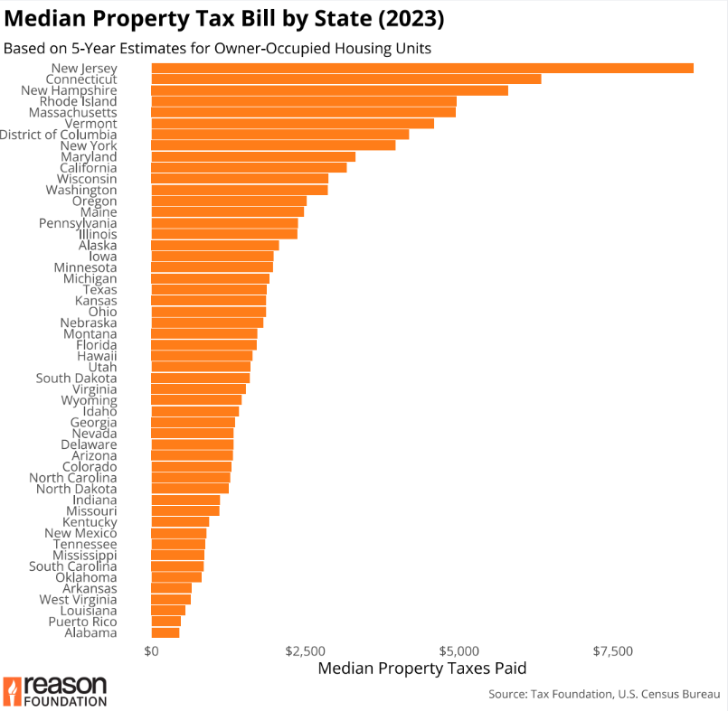

1. Number of homeless people in each state in most recent year

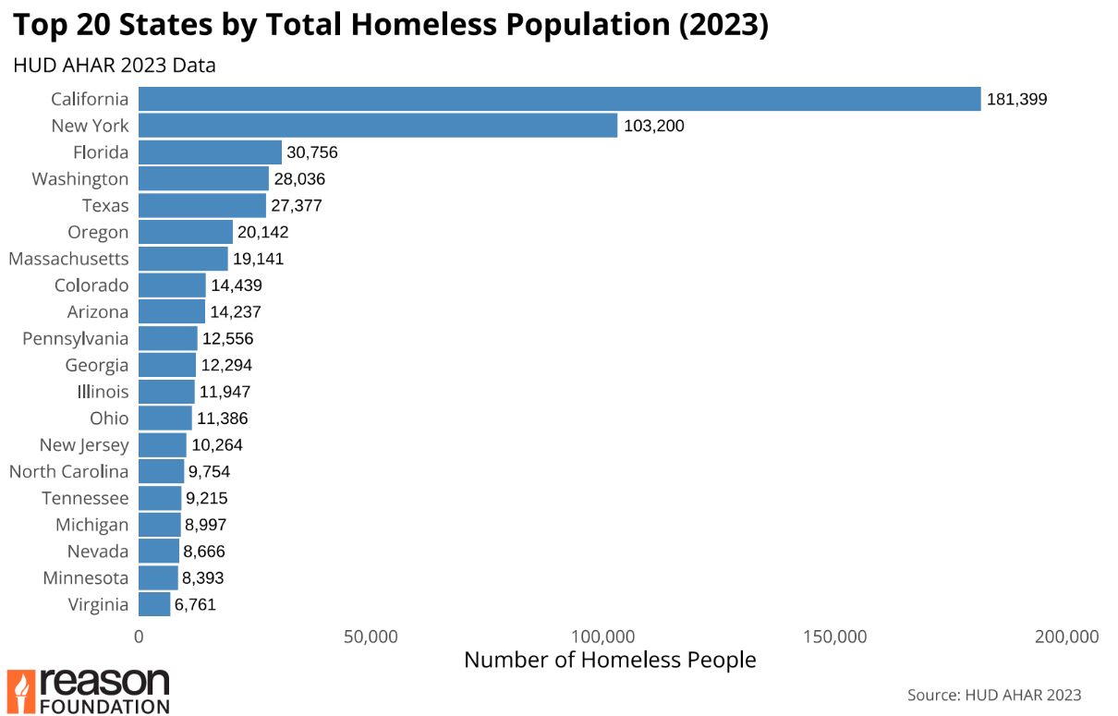

1. Number of homeless people per capita in each state in most recent year

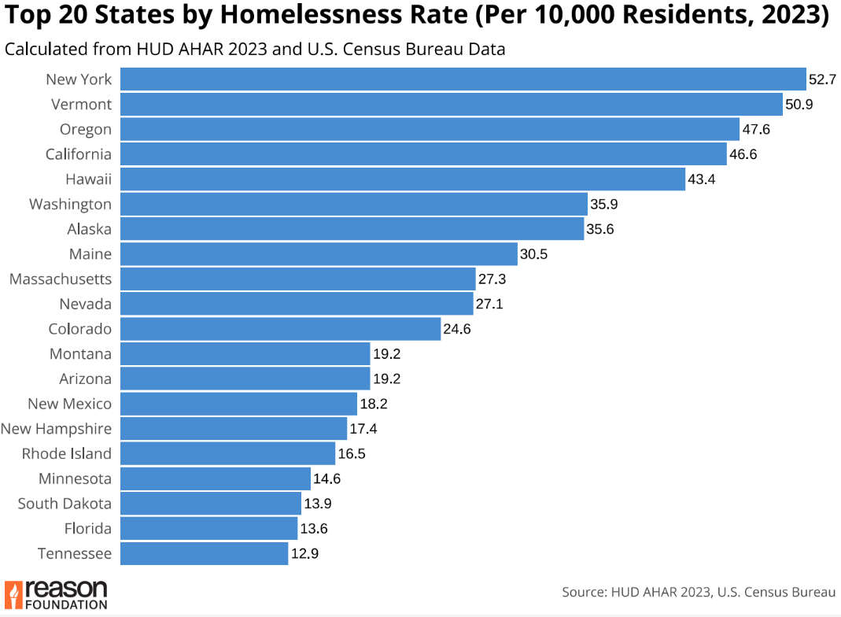

1. Top 10 States: Total Homeless Population vs. State Population (2023)

1. States with the Largest Discrepancy Between Total and Per Capita Homelessness Ranks (2023)

